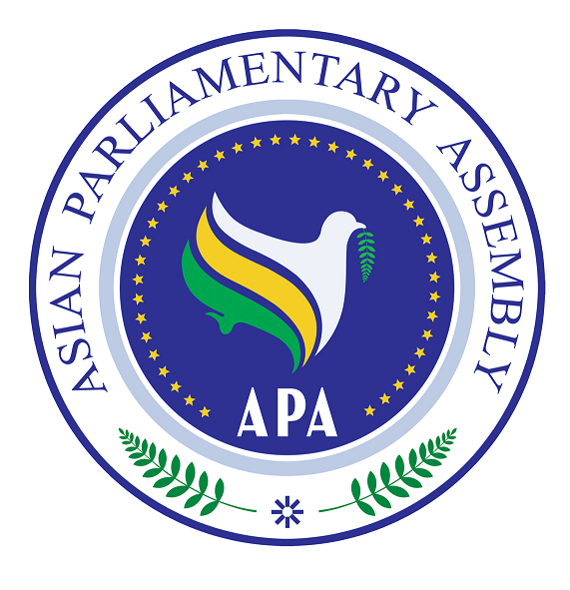  Asian Parliamentary Assembly (APA) | REGISTRATION FORM  Participating in APA Cooperation and Coordination Meeting  At the side of 137th IPU Assembly  9.00-11.00 hours on Saturday, 14 October 2017  Hall No. 16, on the ground floor of the Tavrichesky Palace  (Venue of the 137th IPU Assembly)

Please fill in Capital Letters, one form for each individual participating delegate and return to APA Secretariat by 10 October 2017.
- Delegation of: …………

- Title (please check Mr. Ms. Dr., etc.)
- First Name:
- Last Name:

- Position, in the parliament
- ……………………………………………………………………………………

- Phone No. | - …………………..……………………………………………..  - Country Code - City Code - Number
- Mobile No.  - Fax No. | - …………………………………………………………………  - ………………………………………………………………..
- Email Address: | - ……………….……………………………………………..

Any Proposal on Emergency Item:

Please return to APA Secretariat:
Email : secretariat@asianparliament.org
Fax: 009821 - 26118809

